EXPERIMENT 4

Aim
To design and develop a prototype user interface that includes both familiar and unfamiliar navigation elements and to evaluate how these navigation styles influence usability and overall user experience.
Introduction
Navigation plays a significant role in User Interface (UI) design because it determines how easily users can move within an application and access its various features.
Navigation components can generally be divided into two categories:
- Familiar Navigation – UI patterns that users commonly encounter and already understand.
- Unfamiliar Navigation – new or innovative interaction patterns that may require users to learn them, but can enhance the overall experience when used effectively.
In this experiment, a prototype consisting of three screens was developed:
- Login Page
- Home Page
- Profile Page
The design aims to maintain usability while also introducing modern navigation elements.

Prototype Overview
The prototype includes three screens that were created using a UI prototyping tool.
Screens Included
- Login Screen
- Home Screen
- Profile Screen
These screens demonstrate the use of both traditional and modern navigation styles.

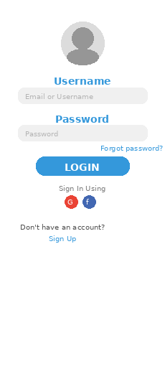 | 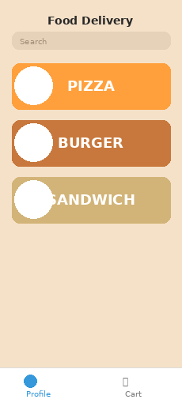 | 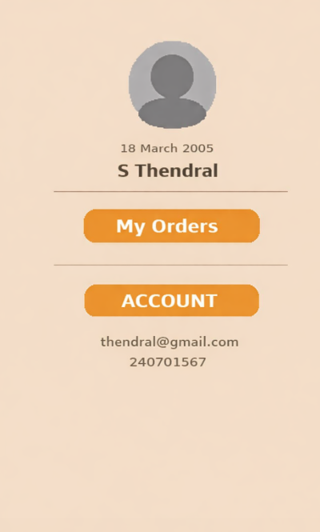
1. Login Page
The Login Page enables users to authenticate themselves and gain access to the application.
Features
- Username or email input field
- Password input field
- Password visibility toggle
- Sign-in button
- Social login options
- Sign-up option for new users
Familiar Navigation Elements
- Standard username and password fields
- Sign In button positioned below the input fields
- Forgot Password link
- Sign Up option for new users
These elements follow commonly used login patterns seen in most applications.
Unfamiliar Navigation Elements
- Card-style login container with a modern layout
- Gradient styled login button
- Social login options displayed below the login section
These elements improve the visual appearance and provide a modern user interface.

2. Home Page
The Home Page functions as the main dashboard where users can browse and explore different content.
Features
- Search bar for quick navigation
- Featured content section
- Latest insights list
- Notification icon
- Bottom navigation bar
Familiar Navigation Elements
- Search bar located at the top
- Bottom navigation bar with icons
- List-based content layout
- Notification icon
These elements are widely used in mobile and web applications.
Unfamiliar Navigation Elements
- Featured content displayed using modern cards
- Dynamic content arrangement
- Horizontal scrolling for content sections
These features create a more engaging and interactive user experience.

3. Profile Page
The Profile Page allows users to view and manage their personal details.
Features
- Profile picture
- User name and email
- Edit profile button
- Profile strength indicator
- Followers and reviews statistics
Familiar Navigation Elements
- Edit profile button
- Profile image display
- User information section
These are standard elements commonly found in user profile pages.
Unfamiliar Navigation Elements
- Profile strength progress indicator
- Statistic cards showing followers and reviews
- Card-based modern layout
These features enhance user engagement and provide feedback regarding profile completeness.

Result
The prototype successfully demonstrates the combination of familiar and unfamiliar navigation elements across the three screens. The design preserves usability while incorporating modern UI features that improve interaction and user engagement.

